## UML Diagrams

### UML Use Case Diagram

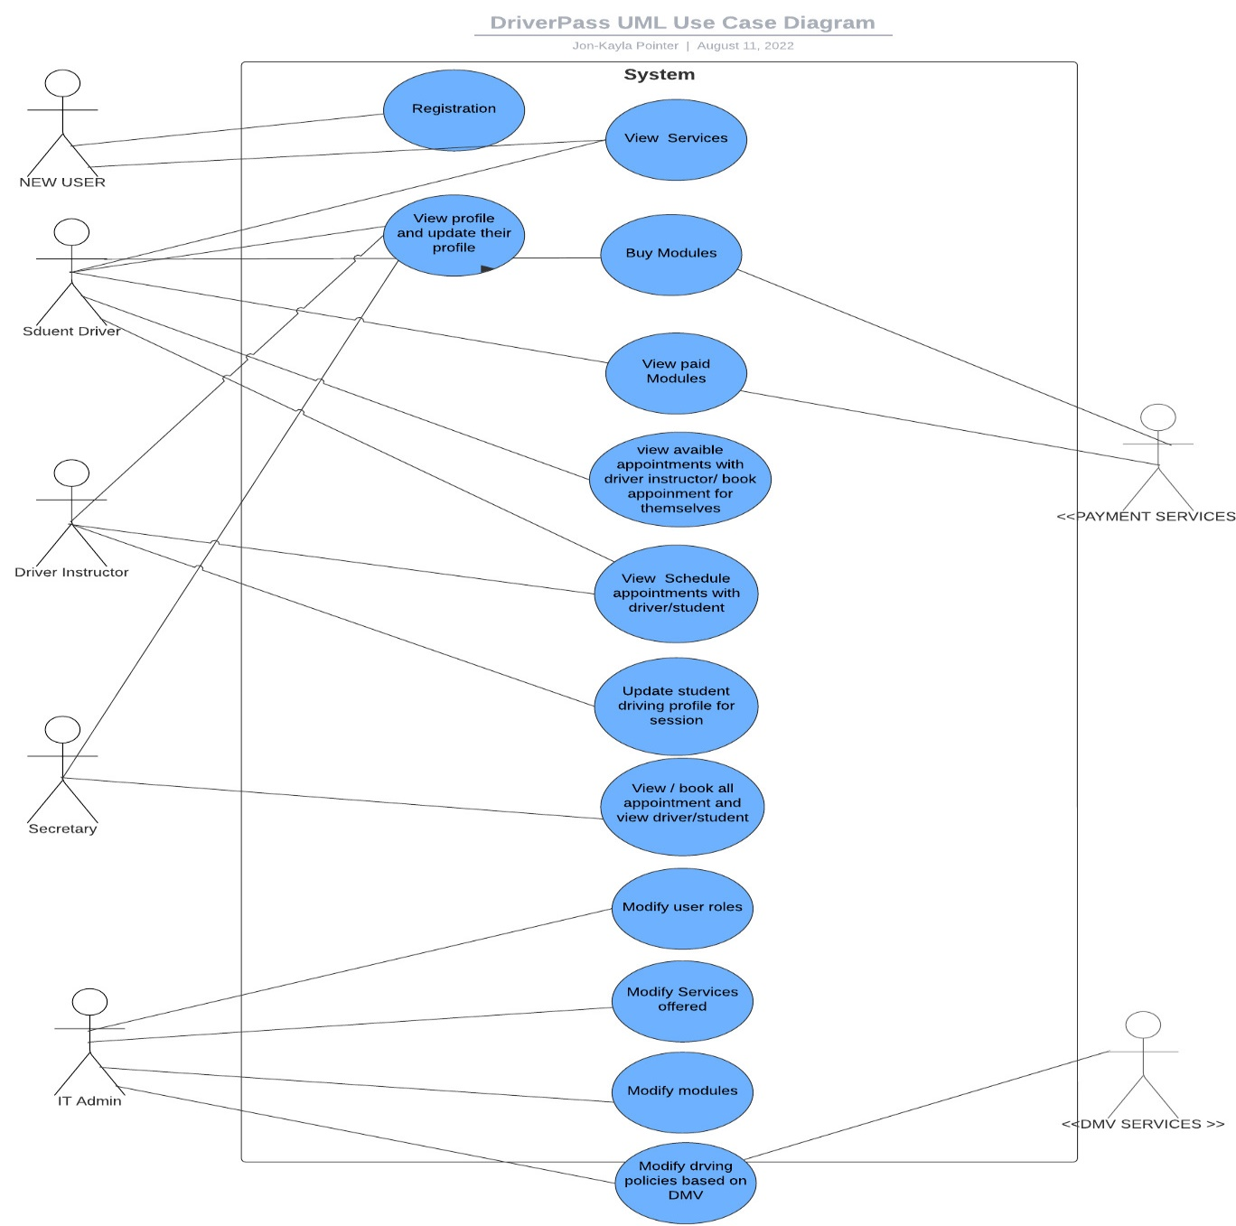

### UML Activity Diagrams

1. Below is a UML Activity Diagram for a customer that is registered and wants to buy a package.

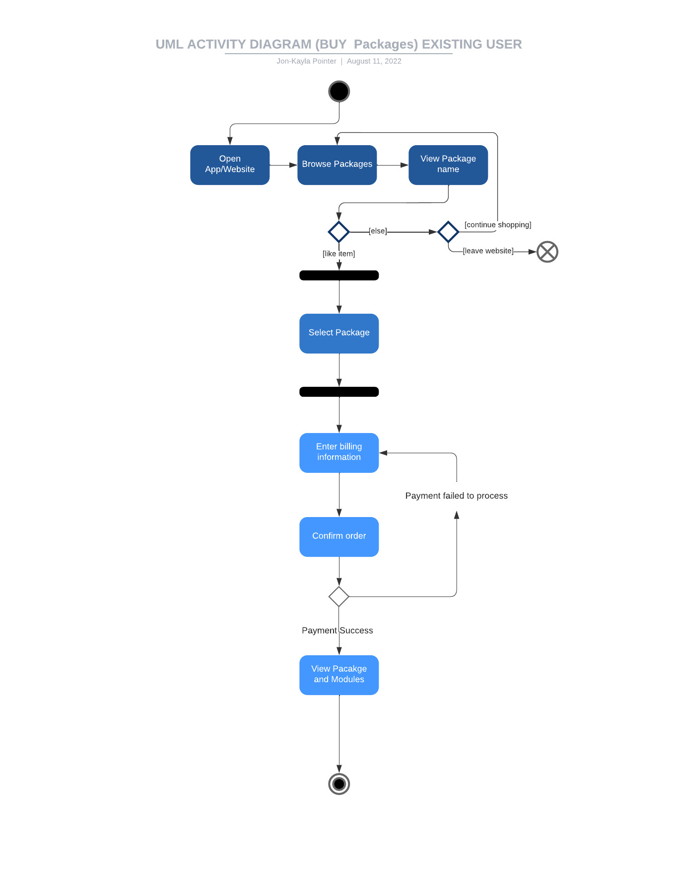

1. Below is a UML Activity Diagram for a paid customer that wants to schedule an appointment.

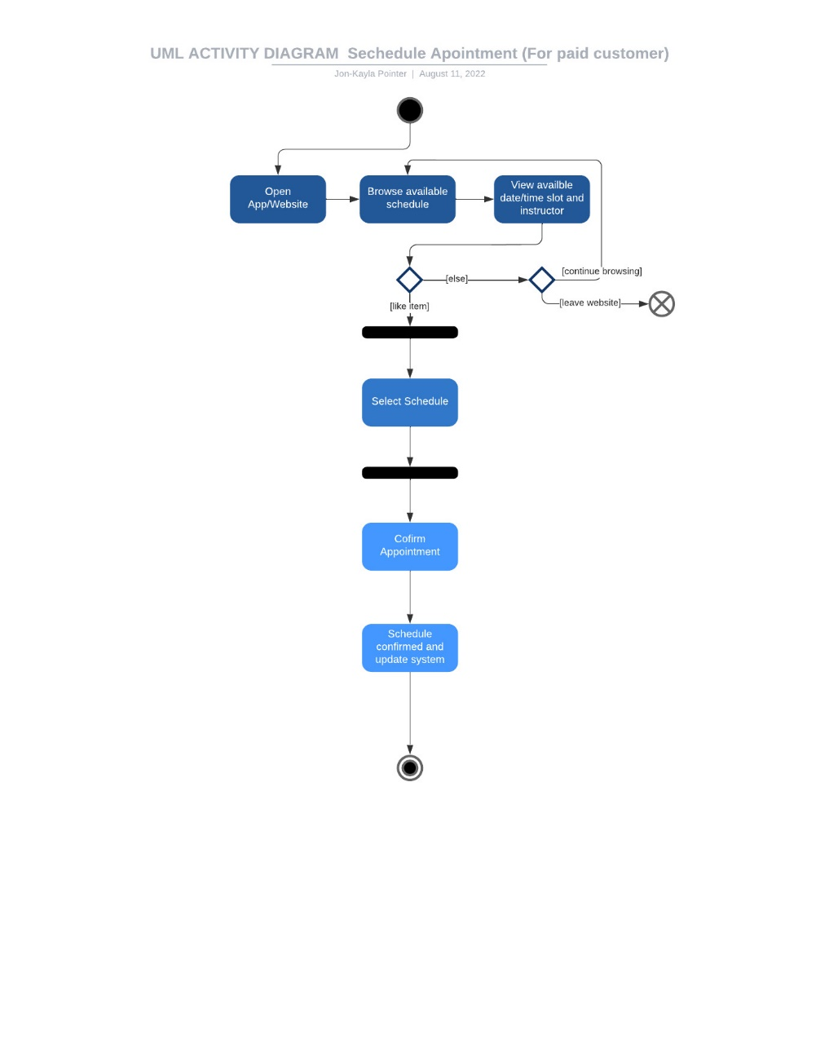

### UML Sequence Diagram

Below is a UML Sequence Diagram for the use case of a customer buying and viewing packages.

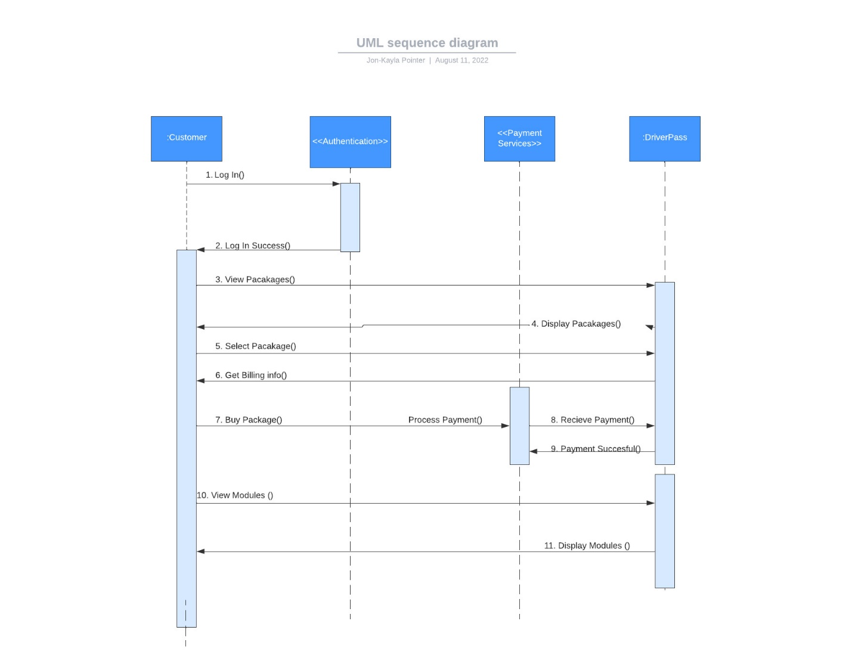

### UML Class Diagram

Below is a UML Cass Diagram.

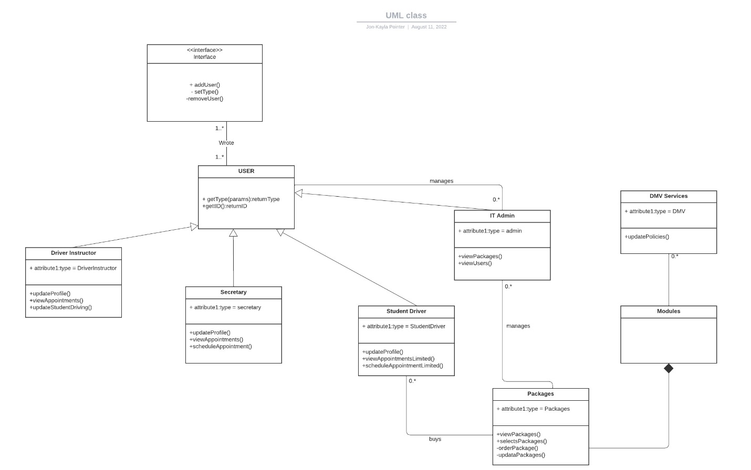

## Technical Requirements

*[Based on the diagrams you have created, describe the technical requirements of your system. These requirements should address the required hardware, software, tools, and infrastructure necessary for your system design.*

### Functional Requirements

* This system should let Student driver use service to be able to buy modules for training and schedule appointments with drivers for hands on practices of driving.
* This system will have the following users:
  + Driver instructor: The driver instructor will be able to view their profile and any scheduled appointments with student. The driver will only be allowed to edit student notes if they are assigned to student driver. They will only be able to write notes about a student and upload it to the session of a student for a certain time. They will be viewing the student profile if they are assigned to that student.
  + Student driver: they are only allowed to edit their payment and personal information. They will be able to view there appointed and drive instructor notes but not edit it. They may schedule an appointment with a driver instructor. They may see if a slot is available or unavailable but may not view who has the slot scheduled. They do not have elevated information system access. They are allowed to see which instructor has a time slot but not the specific student user. Student users may only view modules that they pay for.
  + Secretary user: allowed to view the schedule and see who has the time slot for both student and driver instructor. They will be able make process schedules for driver instructors and student users.

### Software Requirements

* For cost-friendly options this system will deploy this information system via cloud services. There is no additional hardware needed. The only thing that shall suffice is the drive school having an adequate number of computers for their IT staff, driver staff, and secretary. Cloud services is a great option because developers may pay as they go, rather than buying physical servers.
* This system should have cross platform access and work on any browsers.
* This system should use load balancers to ensure availability as well as the use of multiple servers.
* This system should use CASB (Cloud Access Security Broker), secure coding standards, and follow the standards of security set forth in NIST (National Institute of Standards and Technology).

**Tools/Infrastructure:**

* This system should use Microsoft Azure Cloud Services to develop this system.
* This system should use Oauth 2.0 SAML, SSO, or other Authentication Services that are secure and easy for customers to use.
* This system should use payment services like apple pay, Samsung pay, or Pay Pal, for easy in app purchases of the module.
* This system will utilize the necessary protocols and services for users to download modules in the mobile application for offline access of modules.
* This system must use API and communication servers to connect to outside systems such as the DMV, payment services, and Authentication Services.